**Business Problem**

Sales management has gained importance to meet increasing competition and the need for improved methods of distribution to reduce cost and to increase profits. Sales management today is the most important function in a commercial and business enterprise.

**Analysis And Finding**

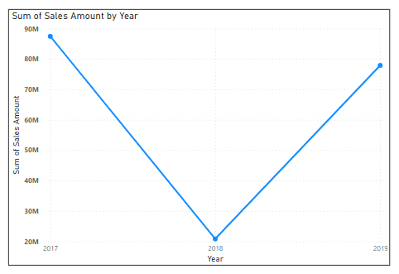1 ) Sales Trend Year Wise

We Have Only 3 Year Data , Fall seen in 2018 , Because 2018 only 3 Month Data Available

2) Sales Trend Month Wise

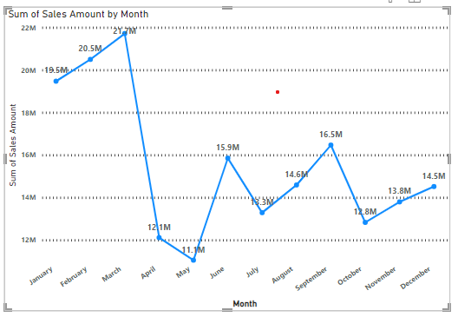

In a April and May Month Fall Seen and again arise in June

3 ) Analysis of Profit of Every Month by Year

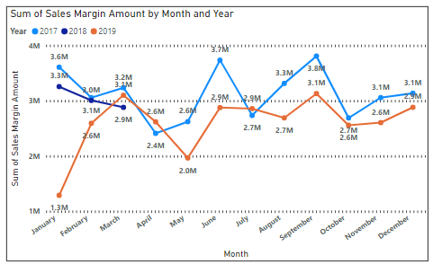

In 2017 Profit Seen high as Compare to 2019

4 ) Discount Amount In Every Month

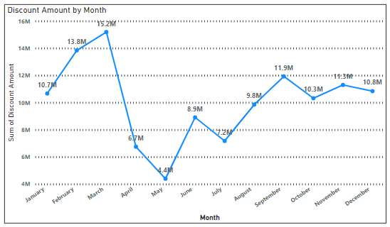

In a April And May Month Too Less Discount given And Co-relation Between Discount and Sales Amount is 9.3 Which Is too High

5) Sales Amount and Discount Amount chart By Year

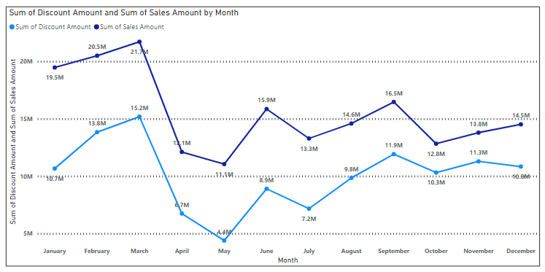

In a April And May Month Sales is Too Low Because Discount Also low

6 ) Bottom Product by Profit

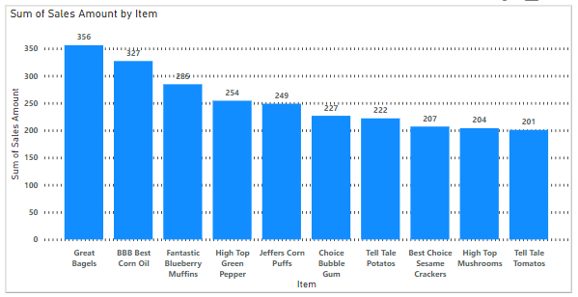

These Are Product which sold top less time

7) Product which cost of sell Amount is high and Profit In Minus

